Roll No: 241901120
Name: L.Ubendra
Department: CSE-Cyber Security

IMPLEMENT PACKET SNIFFING USING RAW SOCKETS IN PYTHON

AIM:
To capture and inspect network packets on a local interface using Python raw sockets — for learning or authorized troubleshooting (show source/destination MAC/IP, protocol, and ports).
PROCEDURE:
1. Confirm you have permission to sniff the target network.
2. Open a raw socket at the link layer (AF_PACKET, SOCK_RAW) to receive frames.
3. Bind the socket to the interface you want to monitor (e.g., eth0).
4. Loop reading packets from the socket.
5. Parse minimal headers (Ethernet → IPv4 → TCP/UDP) to extract addresses/ports.
6. Print/store/analyze the fields you care about.
7. Close the socket and stop when finished.

PROGRAM:
import socket
import struct
import binascii
import textwrap

def main():
host = socket.gethostbyname(socket.gethostname())
print('IP: {}'.format(host))

conn = socket.socket(socket.AF_INET, socket.SOCK_RAW, socket.IPPROTO_IP)
conn.bind((host, 0))

conn.setsockopt(socket.IPPROTO_IP, socket.IP_HDRINCL, 1)

conn.ioctl(socket.SIO_RCVALL, socket.RCVALL_ON)

while True:
raw_data, addr = conn.recvfrom(65536)

dest_mac, src_mac, eth_proto, data = ethernet_frame(raw_data)

print('\nEthernet Frame:')
print("Destination MAC: {}".format(dest_mac))
print("Source MAC: {}".format(src_mac))
print("Protocol: {}".format(eth_proto))

def ethernet_frame(data):
dest_mac, src_mac, proto = struct.unpack('!6s6s2s', data[:14])
return get_mac_addr(dest_mac), get_mac_addr(src_mac), get_protocol(proto), data[14:]

def get_mac_addr(bytes_addr):
bytes_str = map('{:02x}'.format, bytes_addr)
mac_address = ':'.join(bytes_str).upper()
return mac_address

def get_protocol(bytes_proto):
bytes_str = map('{:02x}'.format, bytes_proto)
protocol = ''.join(bytes_str).upper()
return protocol
main()

OUTPUT:
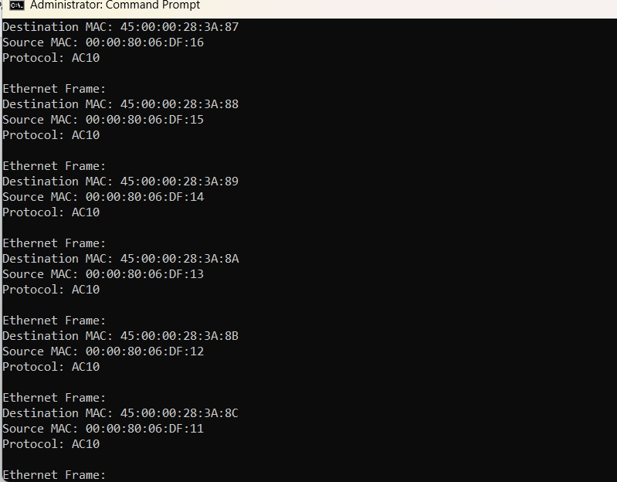

RESULT:
The program shows the source and destination MAC address and protocol of network packets it captures.

